# R Module 4 Rubric

This R Module introduces R Markdown, and is designed to get students comfortable with using the format to produce reports and generate documents. Rather than taking screenshots and pasting into a .docx, students should be able to run code directly in their .Rmd, and have code and figures embedded in their document.

From this point on, students should be using R Markdown. I definitely don’t want to dictate any sort of major change to the syllabus, so that decision is up to you. However, I think using R Markdown, while there is a learning curve, will lead to better code and an easier time trying to debug students’ code and projects.

# Assignment

library(tidyverse)  
library(readxl)  
  
survey <- read_xlsx(path = "data/salary_survey.xlsx")

survey_sub <- survey %>%  
 dplyr::select(`Survey Year`, Country, PrimaryDatabase, SalaryUSD, YearsWithThisDatabase, YearsWithThisTypeOfJob, Education)

survey_sub <- survey_sub %>%  
 dplyr::filter(  
 YearsWithThisDatabase <= 50,  
  
 # Same for the following:  
 YearsWithThisTypeOfJob <= 50,  
  
 # We're only interested in the U.S.  
 Country == "United States",  
  
 # We want to filter out "missing values"  
 Education != "Not Asked",  
  
 # Some respondents put in their hourly wage rather than their yearly salary;  
 # it's doubtful that anyone only makes $13 USD per year working in this kind  
 # of job!  
  
 SalaryUSD > 1000  
 )

survey_sub %>%  
 ggplot(aes(y = Education, x = SalaryUSD)) +  
 geom_boxplot()

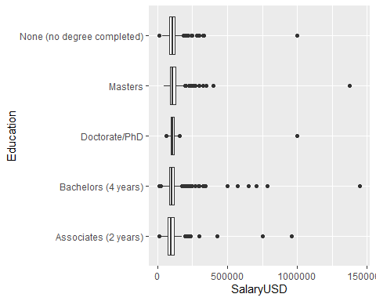

survey_sub <- survey_sub %>%  
 mutate(  
 SalaryLog10 = log10(SalaryUSD)  
 )  
  
  
# We'll pop this back into our boxplots...  
survey_sub %>%  
 ggplot(aes(y = Education, x = SalaryLog10)) +  
 geom_boxplot()

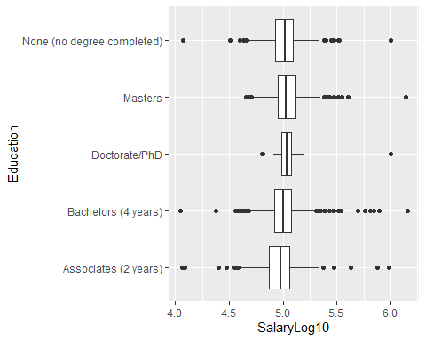

survey_sub$Education <-  
 factor(  
 survey_sub$Education,  
  
 # We set this argument to TRUE when the order of our factor matters, or if  
 # we intend to compare the "amount" of education (a PhD is a greater  
 # "amount" of education than a Bachelors, for example.)  
 ordered = TRUE,  
  
 # The `levels` argument requests a character vector of the different factor  
 # levels in the dataset, and the order we want them to be in.  
 levels = c(  
 "None (no degree completed)",  
 "Associates (2 years)",  
 "Bachelors (4 years)",  
 "Masters",  
 "Doctorate/PhD"  
 )  
 )  
  
  
summary(survey_sub)

## Survey Year Country PrimaryDatabase SalaryUSD YearsWithThisDatabase  
## Min. :2017 Length:4494 Length:4494 Min. : 11100 Min. : 0.00   
## 1st Qu.:2017 Class :character Class :character 1st Qu.: 85000 1st Qu.: 6.00   
## Median :2018 Mode :character Mode :character Median : 102000 Median :10.00   
## Mean :2018 Mean : 107496 Mean :11.31   
## 3rd Qu.:2018 3rd Qu.: 122000 3rd Qu.:16.00   
## Max. :2019 Max. :1450000 Max. :38.00   
## YearsWithThisTypeOfJob Education SalaryLog10   
## Min. : 0.000 None (no degree completed): 671 Min. :4.045   
## 1st Qu.: 3.000 Associates (2 years) : 500 1st Qu.:4.929   
## Median : 5.000 Bachelors (4 years) :2540 Median :5.009   
## Mean : 7.386 Masters : 759 Mean :5.004   
## 3rd Qu.:10.000 Doctorate/PhD : 24 3rd Qu.:5.086   
## Max. :40.000 Max. :6.161

factors <-  
 # The `cut()` function takes a character vector and "cuts" it into a factor,  
 # by looking at values that fall within each break. Think of it as plotting a  
 # histogram with a certain number of bins, and assigning each of those bins as  
 # a factor level.  
 cut(  
 survey_sub$SalaryLog10,  
 breaks = c(4, 5, 6, 7),  
 labels = c("5 Figures", "6 Figures", "7 Figures")  
 )  
  
survey_sub$SalaryFigs <- factors  
  
summary(survey_sub)

## Survey Year Country PrimaryDatabase SalaryUSD YearsWithThisDatabase  
## Min. :2017 Length:4494 Length:4494 Min. : 11100 Min. : 0.00   
## 1st Qu.:2017 Class :character Class :character 1st Qu.: 85000 1st Qu.: 6.00   
## Median :2018 Mode :character Mode :character Median : 102000 Median :10.00   
## Mean :2018 Mean : 107496 Mean :11.31   
## 3rd Qu.:2018 3rd Qu.: 122000 3rd Qu.:16.00   
## Max. :2019 Max. :1450000 Max. :38.00   
## YearsWithThisTypeOfJob Education SalaryLog10 SalaryFigs   
## Min. : 0.000 None (no degree completed): 671 Min. :4.045 5 Figures:2182   
## 1st Qu.: 3.000 Associates (2 years) : 500 1st Qu.:4.929 6 Figures:2309   
## Median : 5.000 Bachelors (4 years) :2540 Median :5.009 7 Figures: 3   
## Mean : 7.386 Masters : 759 Mean :5.004   
## 3rd Qu.:10.000 Doctorate/PhD : 24 3rd Qu.:5.086   
## Max. :40.000 Max. :6.161

survey_clean <- survey_sub %>%  
 # We're not interested in these columns, so we can exclude them with a "-"  
 dplyr::select(-PrimaryDatabase, -Country, SalaryLog10) %>%  
 # Likewise, we want to ignore the cases where the salary is 7 figures, so we set our filter criterion to the observations where SalaryFigs is not (!= represents "is not") "7 Figures".  
 dplyr::filter(SalaryFigs != "7 Figures") %>%  
 # Even though we filtered out the cases of 7-figure salaries, the "7 Figures"  
 # level still exists within our data. We use the `droplevels()` function to  
 # remove unused factor levels. Nothing actually changes about our data itself,  
 # but it helps keep our results tidy.  
 droplevels()  
  
  
summary(survey_clean)

## Survey Year SalaryUSD YearsWithThisDatabase YearsWithThisTypeOfJob Education   
## Min. :2017 Min. : 11100 Min. : 0.00 Min. : 0.000 None (no degree completed): 671   
## 1st Qu.:2017 1st Qu.: 85000 1st Qu.: 6.00 1st Qu.: 3.000 Associates (2 years) : 500   
## Median :2018 Median : 102000 Median :10.00 Median : 5.000 Bachelors (4 years) :2538   
## Mean :2018 Mean : 106616 Mean :11.31 Mean : 7.382 Masters : 758   
## 3rd Qu.:2018 3rd Qu.: 122000 3rd Qu.:16.00 3rd Qu.:10.000 Doctorate/PhD : 24   
## Max. :2019 Max. :1000000 Max. :38.00 Max. :40.000   
## SalaryLog10 SalaryFigs   
## Min. :4.045 5 Figures:2182   
## 1st Qu.:4.929 6 Figures:2309   
## Median :5.009   
## Mean :5.003   
## 3rd Qu.:5.086   
## Max. :6.000

survey_clean %>%  
 ggplot(aes(x = YearsWithThisTypeOfJob, y = SalaryFigs, fill = SalaryFigs)) +  
 geom_boxplot() +  
 facet_grid(rows = vars(Education)) +  
 labs(  
 x = "Years with this type of job",  
 y = "Salary Figures",  
 title = "Years Experience vs. Salary",  
 fill = "Figures"  
 )

